Web Revitalization Program

LOBBYIST DISCLOSURE

Wireframes & Mock-ups

Contents

Subject Matter Registrations 2

Lobbyist Name 3

POH Name 4

POH Communication 5

Beneficiaries 6

Clients/Bus/Org 7

Financial Contributors 8

Advanced Search 9

Subject Matter Details 1 10

Subject Matter Details 2 11

Lobby Registry Details 1 12

Lobby Registry Details 2 13

# Subject Matter Registrations

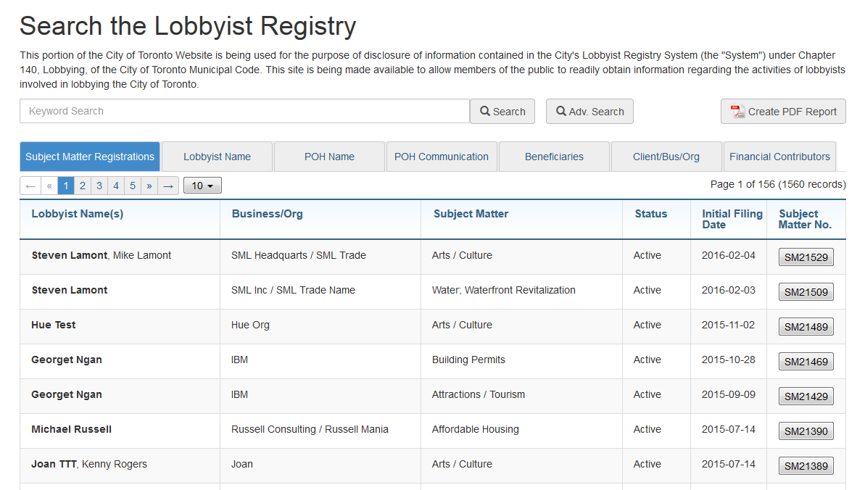

# Lobbyist Name

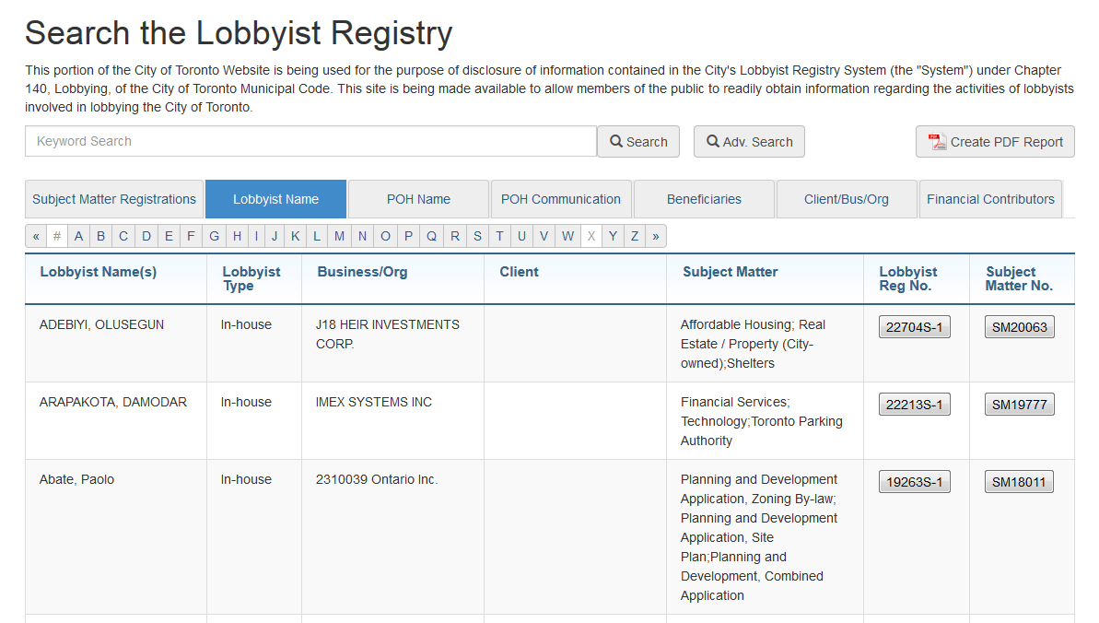

# POH Name

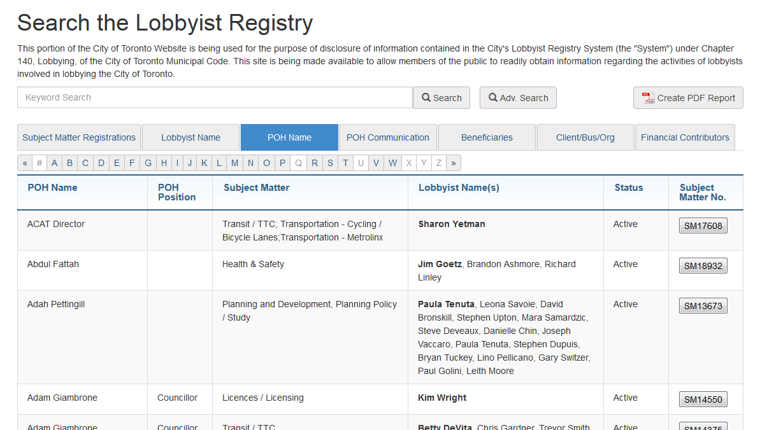

# POH Communication

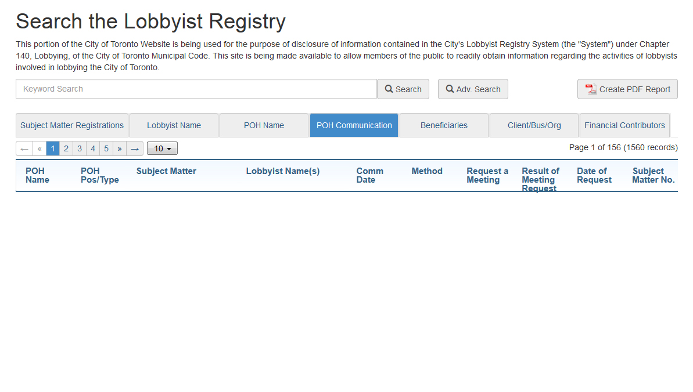

# Beneficiaries

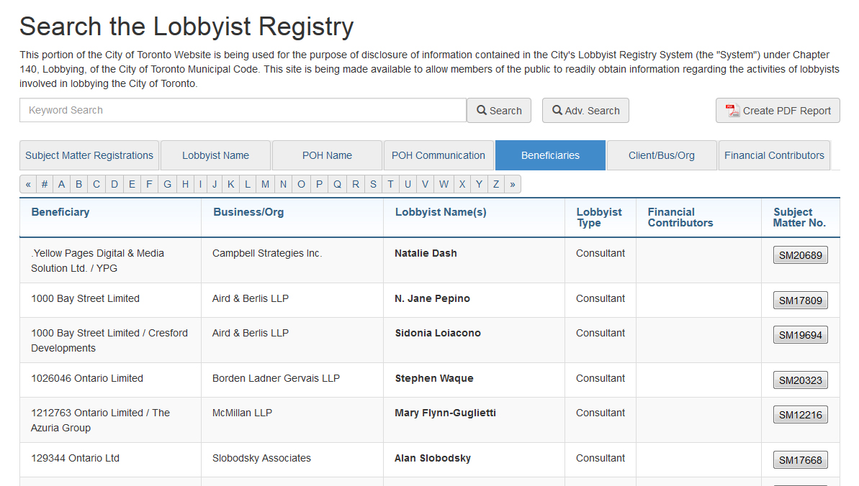

# Clients/Bus/Org

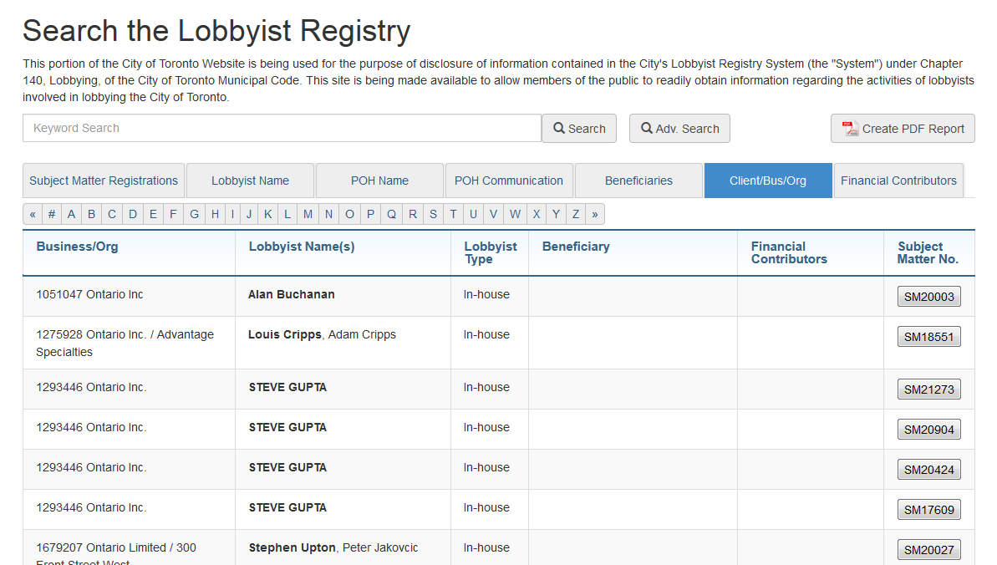

# Financial Contributors

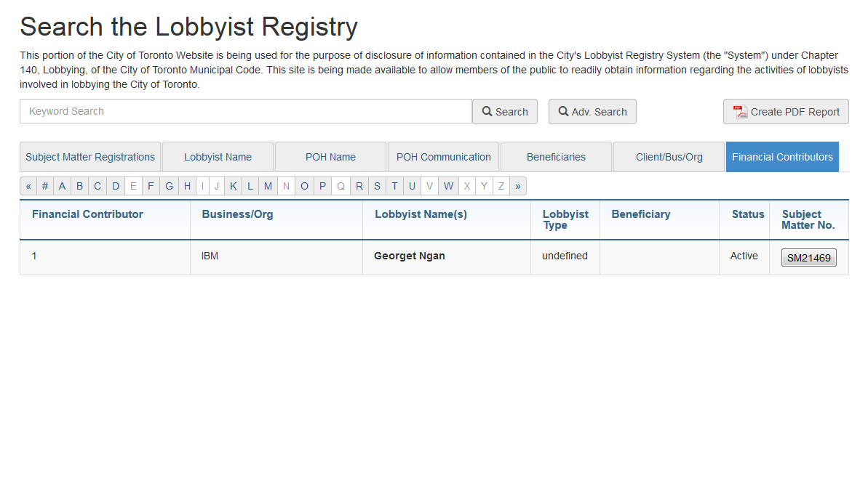

# Advanced Search

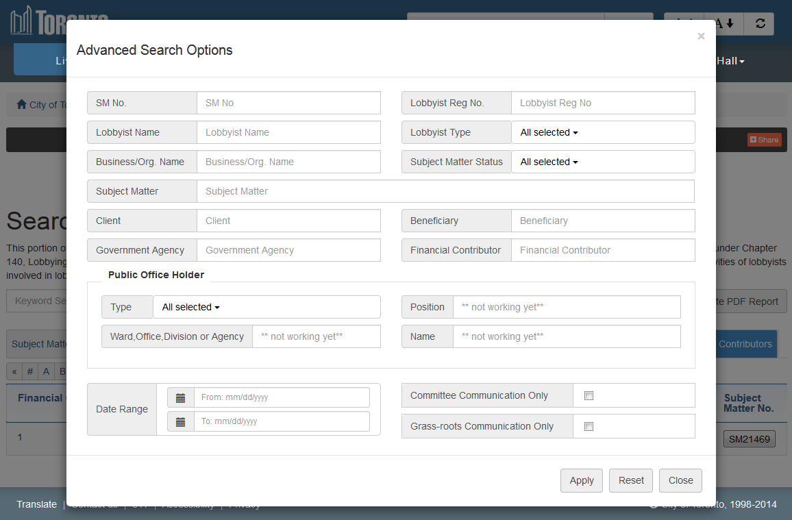

The detail pages for Lobbyist Registration and Subject Matters vary depending on the type of lobbyist action and the information entered. The sub-sections in each report may or may not appear and are included only where there is associated data.

# Subject Matter Details 1

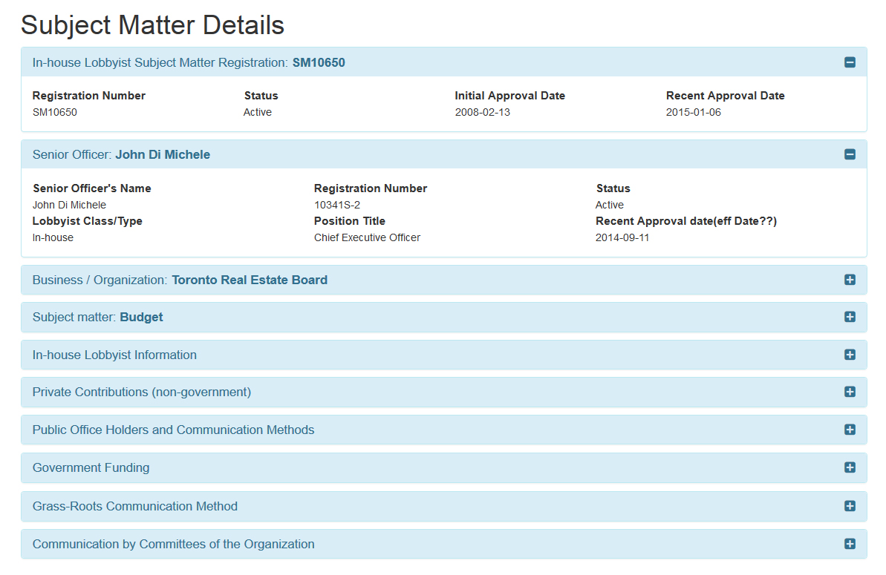

### With tabs expanded

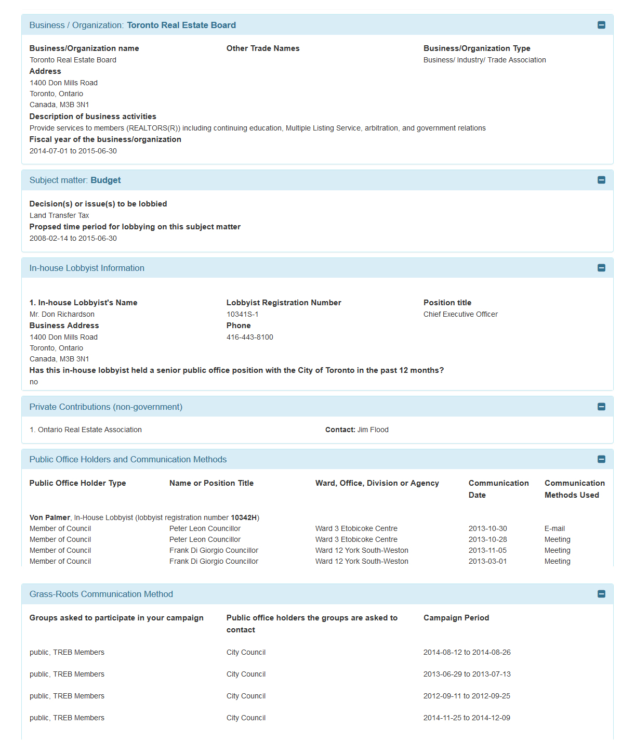

# Subject Matter Details 2

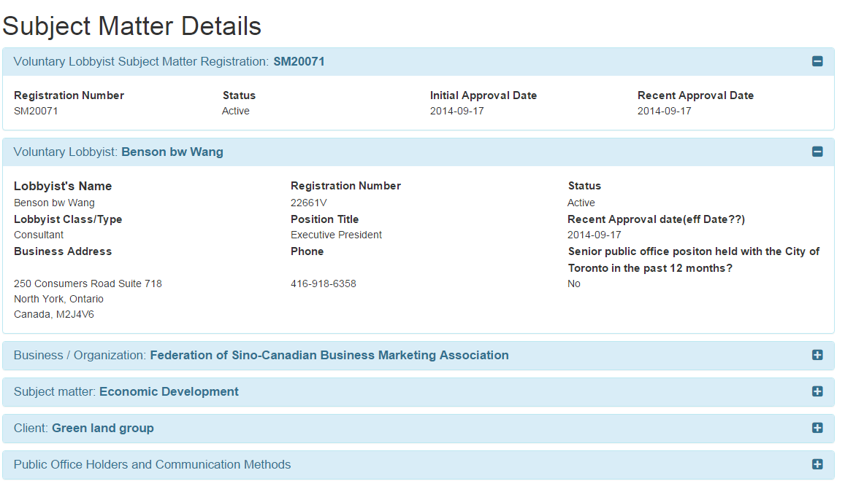

### With tabs expanded

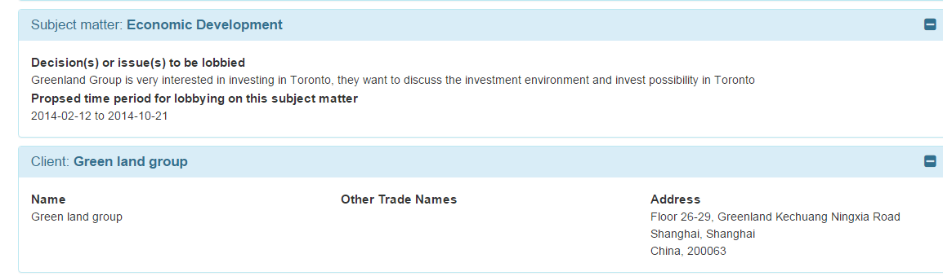

# Lobby Registry Details 1

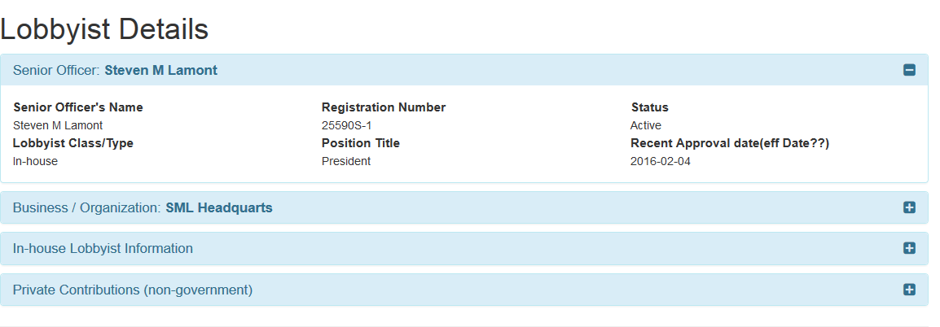

### Tabs expanded

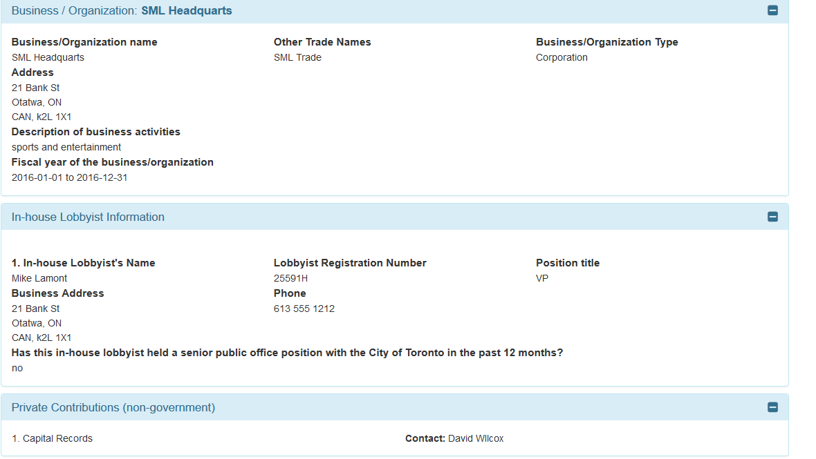

# Lobby Registry Details 2

